JAVA PROJECT

TEAM MEMBERS

Farhat Bin Munsur 24-56328-1

Mohammed Nafiz Sorwar 23-50398-1

Md. Tanver Ahmed 24-56318-1

Sarjil Hasnain 24-56337-1

Supervised by

Md. Khairul Alam Mazumder Sir

SCHOOL MANAGEMENT SYSTEM

**School Management System**

**Users:**

1.Admin/Headteacher

2.Teachers/Employees

3.Students

**Common functionality (for every user):**

1.sign up, log in

2.change password, update personal information.

2.view(read) user data/profile

3.view notice

**Admin can :**

1.create students profile.

2.Delete students any data.

3.create employee profile.

4.Delete employees any data.

5.Create,view,update,delete, and assign classes or sections(6A,9B,10A) and schedules.

6. Manage classes, students, and academic records.

7.Assign students and teachers to specific classes .

8.Assign subjects to classes/sections and link them with teachers.

9.manage students tuition fees.

10.make announcement/notice.

**Teachers can :**

1.view assigned classes and sections.

2.Access the list of students of assign classes and sections.

3.Access the students profile.

4. Enter grades, attendance for students after exams.

5.View student grades, attendance, and progress.

6.upload and update syllabus of specific subject.

**Students can :**

1.view personal detail.

2.view assigned class.

3.view grades, attendance.

4.view subject specified syllabus.

5.check tuition fee.

6.view information of specific teacher.

**System Entities :**

1.User(userID,userName,age,email,phoneNumber,role<student,teacher,admin>,

securityAns, Password)

2.Student(rollNo(ID), dateOfBirth, sectionID(section),gradeID, address)

3.Teacher(teacherID, subjectSpecialization ,salary)

4.Admin(adminType)

5.Subject(subjectID(subjectCode), subjectName)

6.Section(sectionID , studentCount, teacherID, subjectID)

7.Grade(gradeID(grade value) , studentID, subjectID,teacherID)

**Admin,Teacher,Student will inherit User class.

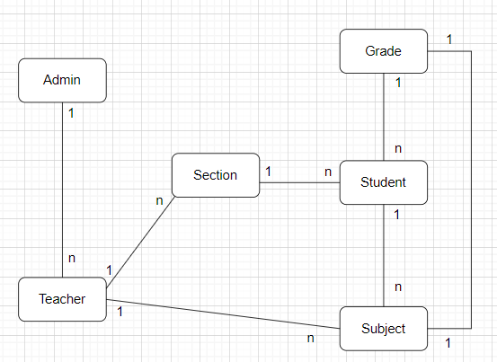**ER Diagram** :